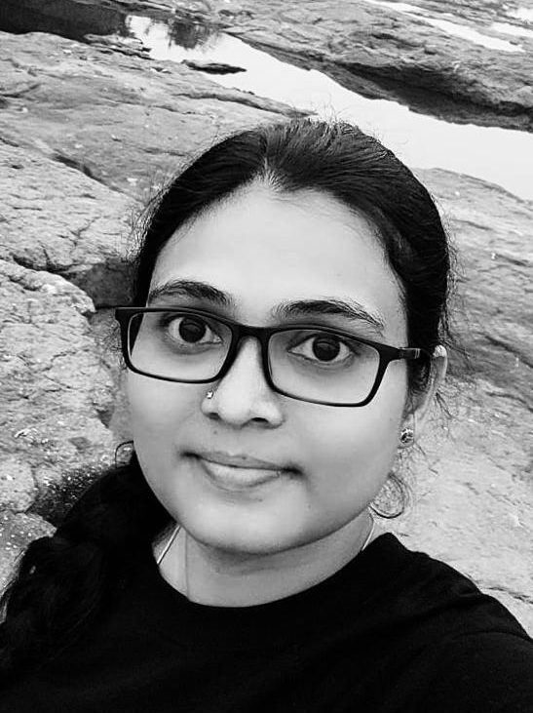

|  |  |
| --- | --- |
| **Personal Information** | |
| Name | Er. SUPRIYA AMOL ANNALDAS (MISS SUPRIYA ANJANAYYA MADDA) |
| Designation | Visiting Lecturer |
| Qualification | B.E., M.E. Structural Engineering. |
| E-Mail ID | supriya.madda@gmail.com |
| **Experience in Years** | |
| Teaching | 1 year |
| Profession | 13 years |
| Research | No |
| Area of Interest | Reading. |
| **Subjects Taught** | |
| UG | Allied subjects in architecture |
| **Publications** | |
| International Journals | No |
| International Conference | No |
| Number of Books Published | No |
| Professional Memberships | No |
| Notable Achievements and Awards | No |